Level 1: PC Tower Case

Power Supply

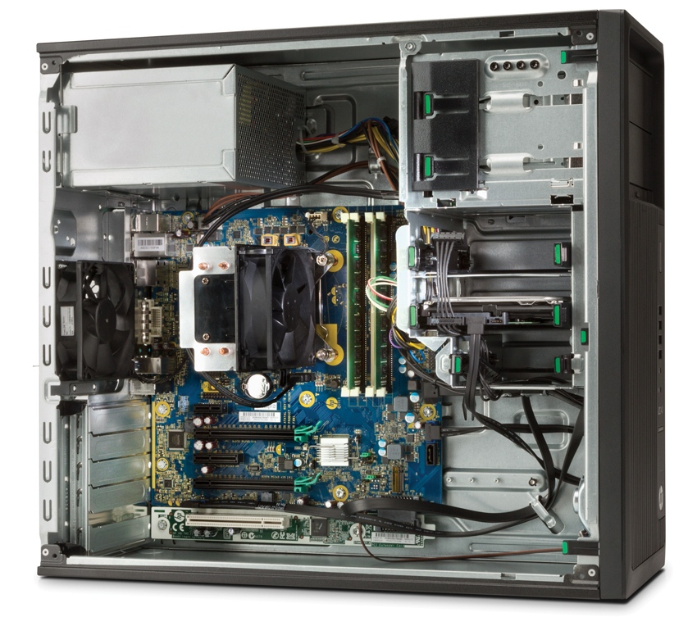

External connector plate

CPU (Under CPU Fan)

USBs, Ethernet, Audio in/out, VGA, DVI, and any other external connectors.

Motherboard

RAM

Memory Slots

Hard Drive

CPU Fan

PCI Expansion Slots

3.

a. When it comes to the capacity and speed of the motherboard I’m going to assume that this is referring to the total amount of RAM the motherboard can support along with the processer, because some motherboards can support up to 32GB and some to 128GB. When it comes to speed, I think the same thing, depends on the ram speed it can support, also depends on the CPU.

b. Lots of different colors :D, pretty much there are more advanced stuff built into the motherboard like built in resets, GUI BIOS.

4.

a. HDDs are incredibly fast, not as fast as an SSD but fast, most modern HDDs in computers are around 7200 RPM with a 64MB cache. They also have large capacities, most are 1TB as a standard, they can go all the way up to 10TB, I personally use a 2TB and its running out of space quickly due to games raging to 50-100GB.

b. One of the biggest things that have changed is the storage size and speed to be completely honest. Not sure what else to say.

Level 2: PC Motherboard

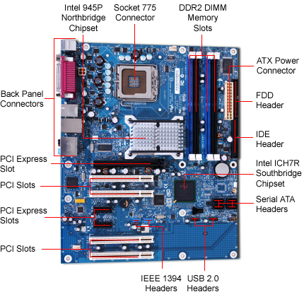

3.

There are so much different CPUs out there today I can’t name them all, although some of the big brands are Intel and AMD. There are sub processor for each thing, for example one might be better for server usage / desktop or editing / gaming or anything else. Most CPUs usually don’t come with integrated graphics but there’s a lot that don’t require them allowing you to save money without having to buy a GPU. For example the Ryzen 7 2700X has no integrated graphics but is a very powerful CPU for gaming when paired with a good GPU. Although if you need one to just normal usage the Ryzen 2200G is pretty good because it has Vega 8 graphics integrated which is pretty good. Speeds can range from 1-4.x GHz most are at 3.5 average. They’ve definitely changed a lot since the 1980s, one big thing being the processing speed, modern day processors can do billions of cycles a second which is insane, they are also quite small, and efficient. They can get very small, for example the CPU in your phone.

4.

Ram is sold in DDR3 an DDR4 today, mostly DDR4 since all the new CPUS require it to even work, let alone it not being backwards compatible between older versions. The main difference between them today is the amount of pins and the speed, a good speed DDR4 ram is 3200MHZ. Like the CPU, the speed and size of the ram is insane. The amount of memory a single stick could hold ranges from 4GB TO 16GB or even more depending on the type. Whether it be server memory or normal desktop. None of that probably made sense when I explained it.

Level 3: Peripheral Devices

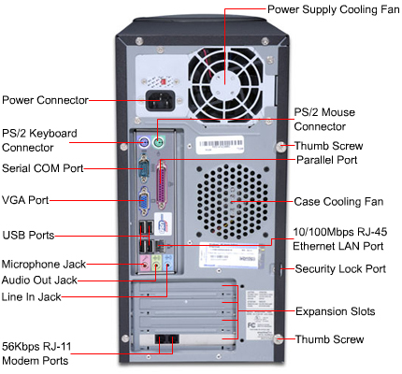

3.

* CRT
* LCD
* LED
  + VGA
  + DVI
  + HDMI
  + USB
  + IDE

Monitors have changed a lot since the 1980s, one of the more noticeable things is the size, most old monitors use CRT, so the big boxy looking monitors. Today monitors are quite thin with high refresh rates like 144Hz or even 240Hz, the resolutions are really high, back then I’d assume 480p or lower was standard, today 1080P is more of the standard when it comes to viewing and gaming, some people go all the way up to 4K. 720 – 1080 – 1440 – 4k, OLED.

4.

**a. Floppy Disk:**

A floppy disk is a disk storage medium composed of a disk of thin and flexible magnetic storage medium encased in a rectangular plastic carrier.

**b. CD-ROM / DVD / Recordable CD / DVD**

CD-ROM. Stands for "Compact Disc Read-Only Memory." A CD-ROM is a CD that can be read by a computer with an optical drive. The "ROM" part of the term means the data on the disc is "read-only," or cannot be altered or erased. (<https://techterms.com/definition/cdrom>)

**c. USB Memory Drives**

A USB flash drive is a device used for data storage that includes a flash memory and an integrated Universal Serial Bus (USB) interface. (https://www.techopedia.com/definition/2322/usb-flash-drive)

**d. Compact Flash Memory**

PCMCIA / PC Card. CompactFlash (CF) is a flash memory mass storage device used mainly in portable electronic devices. (https://en.wikipedia.org/wiki/CompactFlash)

**e. Cloud Based Storage**

Cloud storage is a cloud computing model in which data is stored on remote servers accessed from the internet, or "cloud. (https://www.techopedia.com/definition/26535/cloud-storage)